Module 07 - Part 1: Hands-On Project 13-3: Viewing Windows Hidden Data
7. Click to select a file and display its contents, preferably a user-created document (like a Microsoft Word file). Scroll down under Text data to view the contents that you can read.
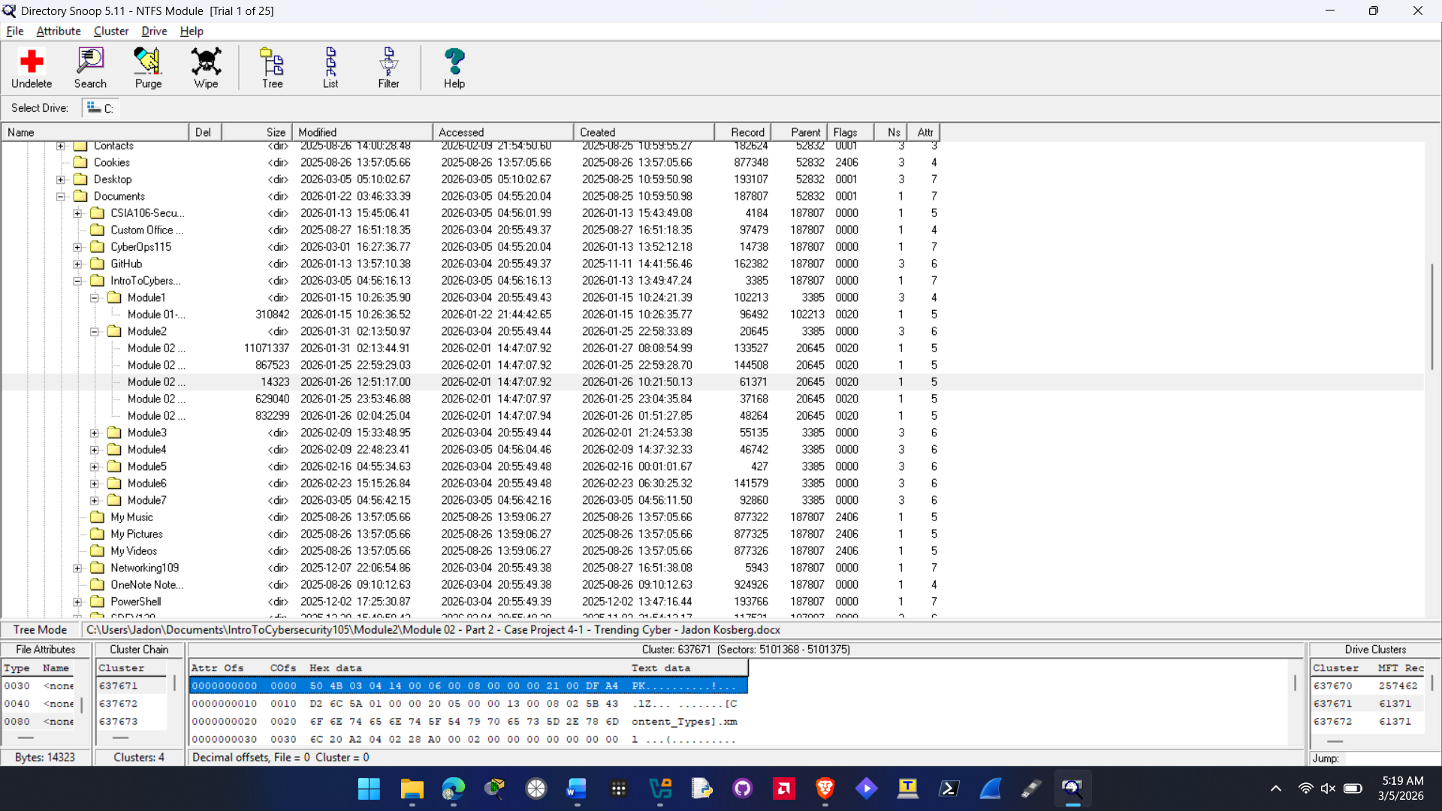
8. Select other files to look for hidden data. Did you discover anything that might be useful to a computer forensics specialist?
There are a couple of features of Directory Snoop that might be useful for computer forensics. You can search through the file system to figure out what is all stored in the directory and see every file that exists on it. You can also recover deleted files using this tool which would be very beneficial for forensics. You can also filter your search based on certain criteria’s this would be useful to forensics if you are trying to look for specific file types or certain data.

18. Click Search in slack area also.
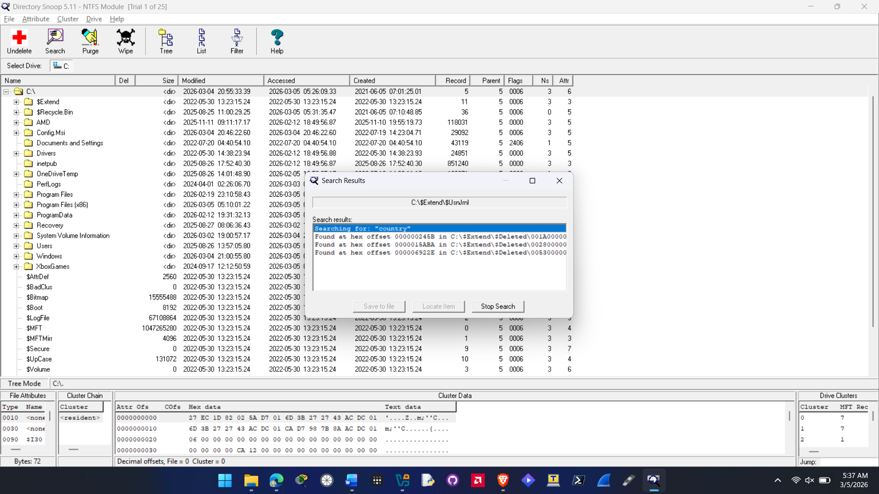
19. Click OK. Was the program able to find this data? Why or why not?
Yes the program was able to find this data. It can find it because they data is still referenced in the deleted directory on my PC so the program is still able to pick that up since the file still technically exists and can still be recovered.

